System Use Case Diagram Description
The use case diagram for the Hotel-Reservations-Web system (Figure 1) illustrates the main interactions between the user, the system, and external hotel data APIs.

- Actors
- User: Interacts with the system to register/login, search for hotels, view AI-recommended deals, and manage bookings.
- System: Handles user requests, communicates with APIs, applies AI logic to optimize results, and displays hotel data.
- External Hotel API Providers: Provide real-time hotel availability, pricing, and details (e.g., docs.hotelapi via etc.).

- Use Cases
- Register/Login:
  - The user securely creates an account or logs in to access personalized features.
- Search for Hotels:
  - The user inputs search criteria such as destination, check-in/out dates,.
- AI Recommendation:
  - The system uses AI to filter and suggest the best hotel options based on user input and preferences.
- Fetch API Data:
  - The system retrieves real-time hotel information from third-party APIs, including room availability and pricing.
- Display Results:
  - The system shows a list of hotels with key details (name, price, images, ratings, etc.) in a user-friendly layout.
- View Booking Details:
  - The user can view detailed hotel information and booking options.
- Manage Profile:
  - The user can update their personal data or view past searches and bookings.

Figure 1 shows how users interact with the system

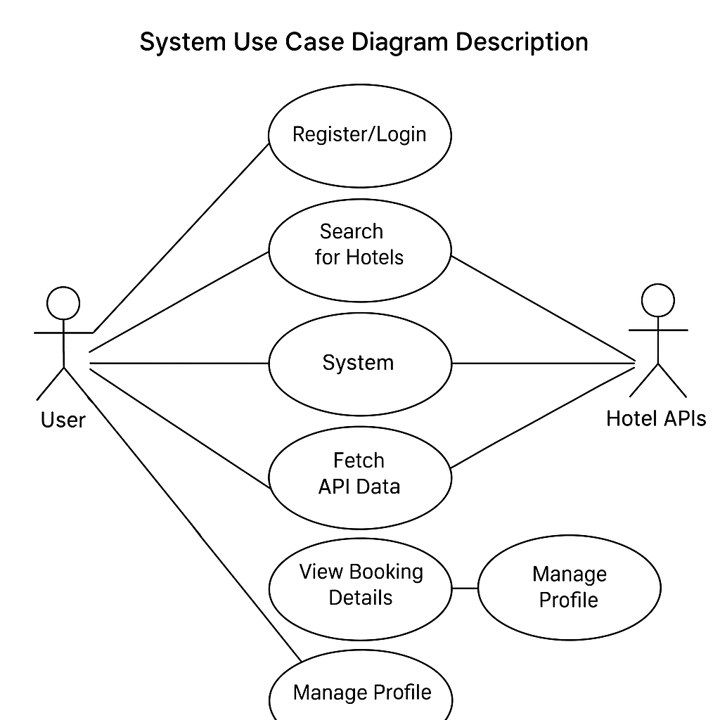
Figure 1: Use Case Diagram – Hotel Reservation System with User-Centric Features

